In addition to providing a development environment box, Vagrant also makes it easy to share and collaborate on these environments. The primary feature to do this in Vagrant is called **Vagrant Share**.

Vagrant share has three main features:

1. **HTTP sharing** creates a URL that will be routed directly into our Vagrant environment.
2. **SSH sharing** allows instant SSH access to our Vagrant environment by anyone by running**vagrant connect --ssh** on the remote side.
3. **General sharing** allows anyone to access any exposed port of our Vagrant environment by running **vagrant connect** on the remote side.
4. Vagrant Cloud
5. Before being able to share our Vagrant environment, we need an account on [Vagrant Cloud](https://vagrantcloud.com/).
6. Once we have an account, we can log in using vagrant login:
7. **$ vagrant login**
8. **In a moment we'll ask for your username and password to Vagrant Cloud.**
9. **After authenticating, we will store an access token locally. Your**
10. **login details will be transmitted over a secure connection, and are**
11. **never stored on disk locally.**
12. **If you don't have a Vagrant Cloud account, sign up at vagrantcloud.com**
13. **Username or Email: k@bogotobogo.com**
14. **Password (will be hidden):**
15. **You're now logged in!**
16. **k@laptop:~/my_vagrant$**
17. Now, it's share time, issue **vagrant share** command:
18. **k@laptop:~/my_vagrant$ vagrant share**
19. **==> default: Detecting network information for machine...**
20. **default: Local machine address: 127.0.0.1**
21. **default:**
22. **default: Note: With the local address (127.0.0.1), Vagrant Share can only**
23. **default: share any ports you have forwarded. Assign an IP or address to your**
24. **default: machine to expose all TCP ports. Consult the documentation**
25. **default: for your provider ('virtualbox') for more information.**
26. **default:**
27. **default: Local HTTP port: 4567**
28. **default: Local HTTPS port: disabled**
29. **default: Port: 2222**
30. **default: Port: 4567**
31. **==> default: Checking authentication and authorization...**
32. **==> default: Creating Vagrant Share session...**
33. **default: Share will be at: ridiculous-frog-9978**
34. **==> default: Your Vagrant Share is running! Name: ridiculous-frog-9978**
35. **==> default: URL: http://ridiculous-frog-9978.vagrantshare.com**
36. **==> default:**
37. **==> default: You're sharing your Vagrant machine in "restricted" mode. This**
38. **==> default: means that only the ports listed above will be accessible by**
39. **==> default: other users (either via the web URL or using `vagrant connect`).**
40. Let's copy the URL ("http://ridiculous-frog-9978.vagrantshare.com") that vagrant share outputted for us and visit that in a web browser. It should load the index page we setup in the previous chapter:
41. 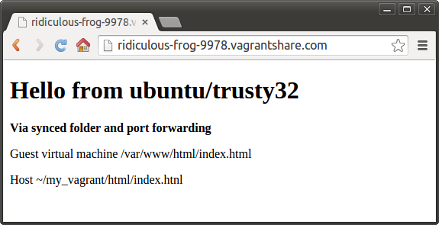
42. Now, modify our **index.html** file and refresh the URL. It will be updated! That URL is routing directly into our Vagrant environment:
43. 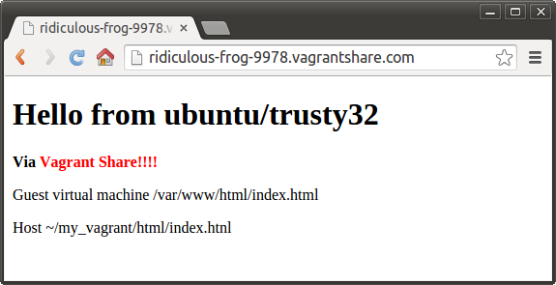
44. To end the sharing session, hit Ctrl+C in our terminal. We can refresh the URL again to verify that our environment is no longer being shared.
45. **k@laptop:~/my_vagrant$ vagrant share**
46. **==> default: Detecting network information for machine...**
47. **...**
48. **==> default: You're sharing your Vagrant machine in "restricted" mode. This**
49. **==> default: means that only the ports listed above will be accessible by**
50. **==> default: other users (either via the web URL or using `vagrant connect`).**
51. **^CExiting due to interrupt.**